PROJECT DEVELOPMENT PHASE
Project Title
Streamlining IT Procurement: Automating Standard Laptop Orders with Flow Designer

1. Flow Creation
- Open ServiceNow.
- Click All and search for Flow Designer.
- Select Flow Designer under Process Automation.
- Click New and select Flow.
- Under Flow Properties, enter the Flow Name as Standard Laptop Task.
- Select Global as the Application.
- Select System User as the Run User.
- Click Submit.
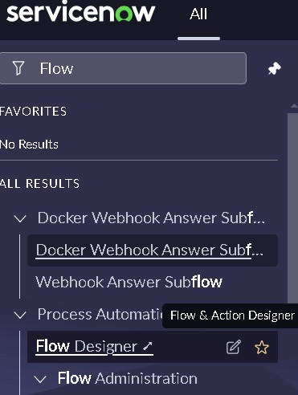
2. Trigger Configuration
- Click Add a Trigger.
- Search for Service Catalog and select it.
- Click Done.
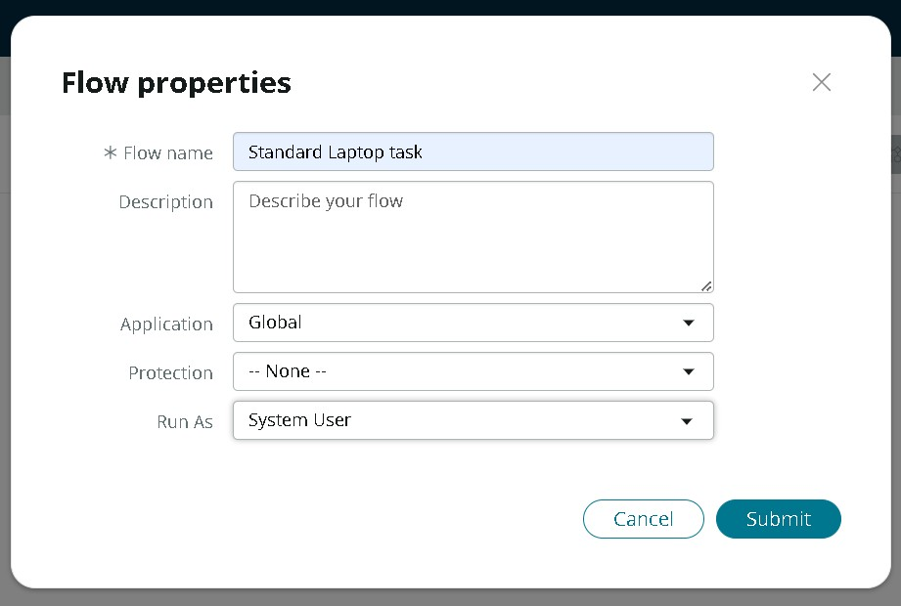
3. Action Configuration
- Under Actions, click Add an Action.
- Search for Create Catalog Task.
- Select Create Catalog Task.
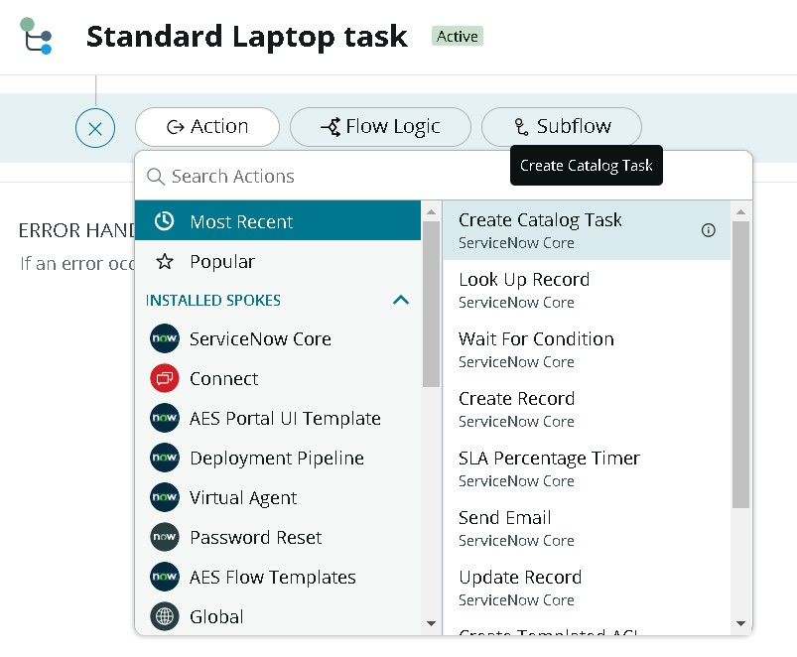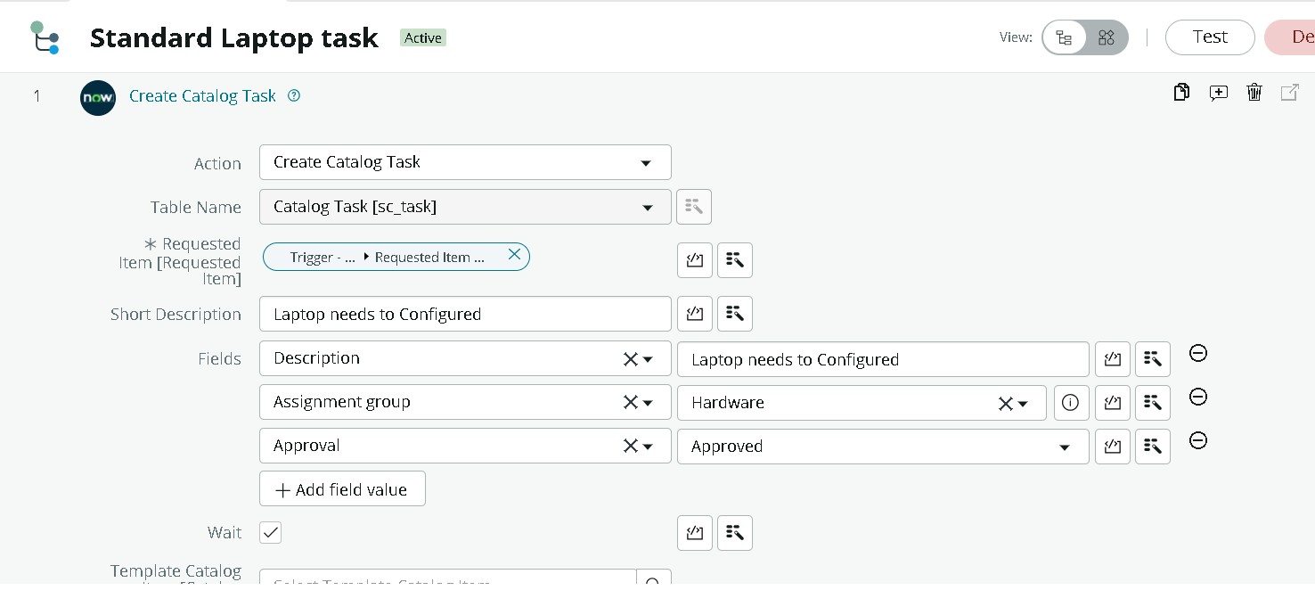
4. Catalog Task Configuration
- Select the action as Create Catalog Task.
- Drag and drop the Requested Item Record into the Request Item field.
- The Table is automatically populated as Catalog Task.
- Enter the Short Description as “Laptop need to Configured”.
- Click Add Field Value.
- Select Description and enter “Laptop need to Configured”.
- Select Assignment Group and choose Hardware.
- Select Approval and choose Approved.
- Leave the remaining fields as default.
- Click Done.
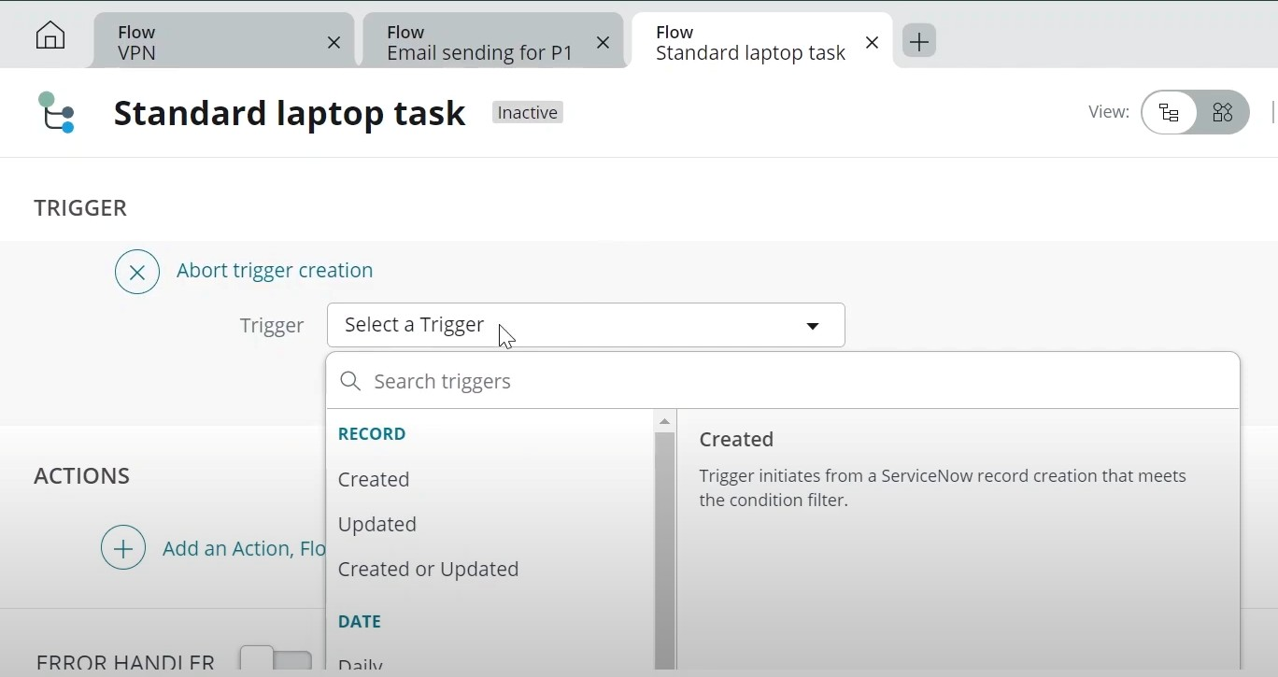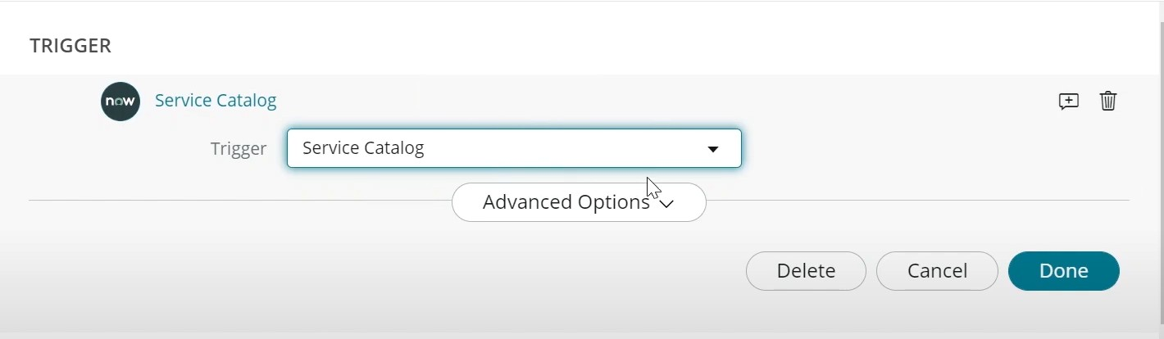
5. Save and Activate the Flow
- Click Save the Flow.
- Click Activate and again click Activate.
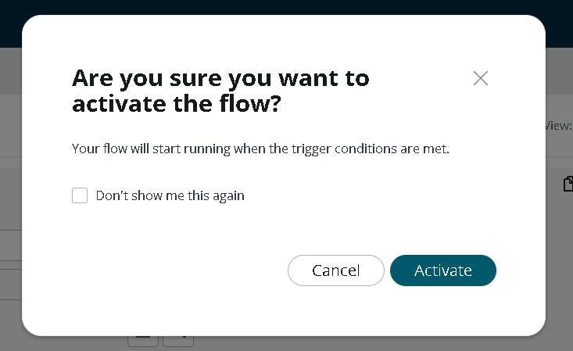

6. Flow Assignment to Standard Laptop
- Open ServiceNow.
- Click All and search for Maintain Items.
- Select Maintain Items.
- Under the Name field, search for Standard Laptop and select the record.
- Select Process Engine.
- Remove the remaining automations and add Flow.
- Add the Flow named Standard Laptop Task.
- Save the record.
